**CHAPTER-1**

**INTRODUCTION**

**CHAPTER -1**

**INTRODUCTION**

**1.1 INTRODUCTION**

In an era of increasing reliance on digital transactions, secure communications and protection of sensitive information, the combination of biometrics and encryption has emerged as a powerful paradigm to provide robust security measures. Integrating biometric data such as fingerprints, facial features, iris scans, or other unique physiological or behavioural characteristics into the encryption process provides a dynamic and highly personalized approach to protecting digital assets. Traditional authentication methods, such as passwords or PINs, are vulnerable to a variety of vulnerabilities, including unauthorized access, phishing attacks, and identity theft. Biometric encryption, on the other hand, uses the inherent uniqueness of an individual's biological characteristics to add an additional layer of security to traditional encryption methods. This convergence addresses the limitations of traditional encryption methods by tying the security of the encryption key directly to the uniqueness of an individual's biometric data. Biometrics, including complex fingerprint patterns, facial features and detailed iris structure, provide a level of personalization and security that exceeds traditional password-based systems. This topic explores the complex synergies between biometrics and cryptography and examines the technologies, challenges and advances that use biometrics as a cornerstone of secure digital communications and data protection. From fingerprint-based encryption to facial recognition encryption systems, we cover the spectrum of biometric technologies that will revolutionize the way we secure, authenticate and transmit sensitive information in the digital age. Exploring this intersection not only improves security, but also provides user-friendly and seamless experiences, an important step towards a future of trusted, personalized and trusted digital ecosystems.

"Encryption with Biometrics" explores the convergence of two powerful areas of security: biometric authentication and encryption. This fusion uses unique biological features, such as fingerprints, iris patterns, or facial features, as encryption keys or elements of the encryption process. This topic explores innovative ways to use individual biometric data to strengthen cryptographic protocols, improve the security and privacy of digital transactions, store data, and control access. The use of biometrics in encryption represents a paradigm shift in security mechanisms that use the uniqueness and durability of biological characteristics to strengthen cryptographic systems. By incorporating biometrics into the encryption algorithm, this approach aims to improve the authentication process while protecting sensitive information from unauthorized access or tampering. This topic covers various biometric technologies, encryption methods, implementation issues, and the potential to create robust security architectures using biometrics as an integral part of cryptographic protocols.

Exploring the combination of biometrics and encryption can enable a private, secure and easy-to-use authentication experience that will transform the way we protect and access data in a world where privacy and security are paramount. This topic discusses the complexities, benefits, challenges, and future implications of incorporating biometric data into encryption schemes, leading to an era where an individual's biological characteristics become the foundation of digital security.

**1.2 MOTIVATION**

The motivation to research “biometric encryption” stems from the constant need for reliable, personalized, and secure methods to protect sensitive information in the digital world.

Cyber ​​threats are constantly evolving and require advanced security measures. Encryption with Biometrics explores a dynamic approach that goes beyond traditional encryption methods to address emerging threats in the digital environment.

Biometric authentication provides a more user-centric approach to security. This uses a person's unique biology to provide convenience and reduce the need for people to remember complex passwords or keys.

Biometric encryption aims to protect privacy by securely storing sensitive biometric information and ensuring that the biometric data itself acts as a key or credentials for encryption and cannot be accessed directly.

As data protection and privacy regulations become more stringent (e.g. GDPR, HIPAA, etc.), research into innovative yet compliant security measures becomes essential, making encryption using biometrics an important area. The motivation for research in biometric cryptography lies in its potential to revolutionize security paradigms and provide reliable and personalized approaches that meet the needs of modern digital ecosystems.

**1.3 PROBLEM STATEMENT**

Securing sensitive files demands an innovative approach to encryption. Conventional methods using passwords or cryptographic keys pose vulnerabilities. The challenge is to create an advanced file encryption system that extracts a private key from biometric features—such as fingerprints or facial recognition.

This solution aims to enhance security by binding file access directly to a user's unique biometric identity, minimizing risks associated with traditional approaches. The objective is to develop a seamless integration that ensures robust file confidentiality and integrity through biometric-based encryption.

**1.4 OBJECTIVE**

Using biometric data for encryption purposes can improve security by leveraging unique biological characteristics.

Enhanced security: Enhance security measures by using biometric data (eg fingerprint, iris scan, facial recognition) as the encryption key. Because biometrics are unique to each individual, they add an extra layer of protection compared to traditional passwords or codes.

Authentication accuracy: Use biometrics to increase authentication accuracy while reducing the likelihood of unauthorized access. Biometric encryption ensures that only authorized individuals with verified biometric markers can access encrypted data.

Privacy protection: Protect sensitive information by encrypting biometric data. Since decryption requires a person's physical characteristics, it helps maintain data privacy.

Resistance to unauthorized access: Biometric encryption helps reduce the risk of unauthorized access due to stolen passwords or compromised keys. Biometric data provides a higher level of protection against identity theft because it is difficult to copy or forge.

Convenience and user experience: Improve the user experience by providing a seamless and easy-to-use login process. Using biometrics for encryption eliminates the need to remember complex passwords or carry physical keys.

Minimize data breaches: Use biometric encryption to reduce the likelihood of data breaches. This makes it much more difficult for hackers to access sensitive information stored in the system or database. Adaptability and scalability: Create encryption systems that adapt to a variety of biometric methods and scale across devices and platforms, ensuring flexibility and broad adoption.

**CHAPTER- 2**

**LITERATIRE SURVEY**

**CHAPTER-2**

**LITERATURE SURVEY**

This literature review serves as a basic compass to guide our understanding of past and current research and to shape the trajectory of our research

**2.1 OVERVIEW**

Biometric encryption involves the use of unique biological characteristics to secure and protect sensitive information. An overview of how this process works:

Biometric data is collected through a variety of methods, including fingerprints, iris scanners, facial recognition, voice recognition, and even behavioral patterns such as typing rhythm or gait analysis. The captured biometric data is converted to digital format and processed to generate encryption keys. These keys are unique to each individual and are used to encrypt or decrypt sensitive data. Confidential information is encrypted using biometric keys before it is stored or transmitted. This process encrypts your data, making it unreadable without the proper decryption key. To access the encrypted data, the biometric information of the authenticated user is verified. The system compares the transmitted biometric data with the stored reference data. If the comparison matches an acceptable threshold, a decryption key is generated to access the data.

Biometric encryption improves security over traditional password-based systems. Since biometric characteristics are unique to each individual, they are very difficult for unauthorized users to access. This is because these features are very difficult to copy or counterfeit.

**2.2 LITERATURE SURVEY**

**1.** **Synthetic biometrics: A survey**

The article, titled "A Survey of Synthetic Biometrics: Fingerprints, Faces, Iris, and Vascular Patterns," is a comprehensive overview of the current state of synthetic biometrics research. Authors Andrejs Makrushins, Andreas Uhl, and Jana Dittmann provide an in-depth analysis of the benefits, use cases, and challenges associated with the use of synthetic biometric samples. This article first discusses the motivations behind the use of synthetic biometric samples, which include addressing privacy concerns, enabling large-scale evaluation, and reducing sample collection efforts. The authors then provide a detailed overview of the development of neuro regenerative models and their implications for synthetic biometrics research. They also emphasized the importance of quality indicators in evaluating the suitability of synthesized samples. The authors then classify and summarize the most prominent studies of synthetic biometrics, focusing on fingerprint, facial, iris, and vascular pattern samples. They also provide an overview of traditional modeling studies used to create synthetic biometric samples as well as data-driven image generation techniques used in contemporary research. The paper concludes with a discussion of existing public synthetic bio identification datasets and synthesis tools, and a summary of key findings and future research directions. Overall, this article is a valuable resource for researchers and practitioners in the field of synthetic bio identification.

**2. A Development of fingerprint based biometric cryptography**

This paper explores innovative ways to integrate fingerprint biometrics into cryptographic systems to increase security and improve authentication processes. This article introduces the concept of biometric encryption and highlights the importance of fingerprints as unique identifiers. This highlights the need for secure encryption systems that use biometric data to improve authentication and data protection. This article describes the process of registering a user's fingerprint, capturing its characteristics, and converting them into an encryption key or pattern. This specifies that the generated encryption key is stored securely in the system database, emphasizing the uniqueness of the key corresponding to each individual fingerprint. Methods of protecting these keys against unauthorized access or manipulation are being investigated. This article explains how to use fingerprint-based encryption keys in encryption and decryption processes to provide secure communications or data storage.

**3. Facial Image Encryption for Secure Face Recognition System**

This article explores the important area of ​​using encryption techniques to protect facial images used in facial recognition systems. We are exploring encryption techniques applied to facial data to protect privacy and improve the security of the facial recognition process. This exposes facial image vulnerabilities during storage and transmission and requires strong encryption methods. This article details different methods of adaptive facial image encryption. Symmetric and asymmetric encryption, homomorphic encryption, and visual encryption are considered safeguards while retaining facial recognition capabilities. An important aspect to discuss is the balance between encryption and maintaining facial recognition capabilities. In this paper, we explore ways to encode facial images while preserving important facial features or features necessary for accurate recognition. Improving the decoding process in secure facial recognition systems. This involves decrypting authorized facial images to extract the original data for recognition purposes while protecting against unauthorized decryption. This article addresses security issues related to encrypted facial data, including protection against attacks such as brute force decryption or adversarial attacks that aim to compromise recognition accuracy. Privacy implications and potential risk mitigation measures are also discussed.

**4.** **Robust Fingerprint Minutiae Extraction and Matching Based on Improved SIFT Features.**

In this survey article, the authors review the current state of synthetic biometric research, focusing on fingerprint, facial, iris, and vascular pattern samples. They first discuss the rationale for using synthetic biometric samples, which include addressing privacy concerns, enabling large-scale evaluation, and reducing sample collection efforts. The authors also provide an overview of the development of neuro regenerative models and their implications for synthetic bio identification research. The paper then provides a detailed overview of traditional modeling studies to obtain synthetic biometric samples, as well as data-driven image generation methods used in modern studies. The authors categorize and summarize the most prominent research on synthetic biometrics and outline the benefits, use cases, and challenges associated with the use of synthetic biometric samples. The article concludes with a discussion of existing public synthetic bio identification datasets and synthesis tools, as well as a summary of key findings and future research directions. Overall, this comprehensive survey paper is a valuable resource for synthetic biological identification researchers and practitioners. In this article, the authors review various studies and datasets related to synthetic biometric technology. They discuss the motivation for using synthetic biometric samples and the development of neuro regenerative models. They also emphasized the importance of quality indicators in evaluating the suitability of synthesized samples. The article concludes with a discussion of the availability of public synthetic biometric datasets and synthesis tools. It provides an overview of traditional modeling studies for obtaining synthetic biometric samples, as well as data-driven image generation methods used in modern studies. Overall, this research paper provides a comprehensive resource for synthetic bio identification researchers and practitioners.

**5.** **An Image Feature Extraction to Generate a Key for Encryption in Cyber Security Medical Environments**

The paper "An Image Feature Extraction to Generate a Key for Encryption in Cyber Security Medical Environments" presents a new encryption method for medical images in cyber security medical environments. The method involves extracting image features and using them to generate a key for encryption. The encryption process starts with edge detection and bit division into (3×3) windows. Diffusions on bits are then applied to create the key used for encrypting the edge image. The key is tested for randomness using NIST randomness tests to ensure its acceptance as true. The encryption process is reversible for decryption and retrieval of the original image. The encrypted image can be used in any cyber security field, including healthcare organizations. The proposed algorithm has shown to improve encryption efficiency and has good security performance, with a higher information entropy of 7.42 and a lower correlation coefficient of 0.653.

**CHAPTER-3**

**SYSTEM REQUIRENMENTS**

**CHAPTER-3**

**SYSTEM REQUIRENMENTS**

System requirements are a crucial part of any software development process. They detail the specific needs of the software, including hardware, operating systems, and other software necessary for the program to function correctly.

**3.1 Software Requirements**

Software requirements deal with defining software resource requirements and prerequisites that need to be installed on a computer to provide optimal functioning of an application.

The following are the software requirements for the application:

* Operating System: Windows 10
* Java Development Kit
* Android Studio

**Hardware Requirements**

The most common set of requirements defined by any operating system or software application is the physical computer resources, also known as hardware.

* CPU: Intel or AMD processor
* Cores: Dual-Core (Quad-Core recommended)
* RAM: minimum 4GB (>4GB recommended)
* Graphics: Intel Integrated Graphics or AMD Equivalent

Display Resolution: 1366x768 (1920x1080 recommended.

**3.2 Functional and non-functional Requirements**

**Functional requirements**

Functional requirements for BIO-CRYPT, which utilizes biometric data for encryption and authentication, may include the following:

1. Biometric Data Capture: The system should be able to capture biometric data such as fingerprints, iris scans, or facial features accurately and securely.

2. Biometric Key Generation: The system should generate encryption keys based on the unique biometric data captured from authorized users.

3. Encryption and Decryption: The system should be able to encrypt and decrypt confidential information using the biometric keys generated from the biometric data.

4. Authentication: The system should authenticate users based on their biometric data to grant access to encrypted data or secure systems.

5. Access Control: The system should control access to sensitive information or systems based on successful biometric authentication.

6. User Management: The system should allow for the management of user biometric data, including enrollment, deletion, and updates.

7. Audit Trail: The system should maintain an audit trail of biometric authentication events for security and compliance purposes.

8. Error Handling: The system should have mechanisms in place to handle errors during biometric data capture, key generation, encryption, decryption, and authentication processes.

9. Data Protection: The system should ensure the protection of biometric data, encrypted data, and sensitive information from unauthorized access or disclosure.

These functional requirements are essential for the successful implementation of a biometric encryption and authentication system like BIO-CRYPT, ensuring that it meets the necessary capabilities to securely protect data using biometric technology.

**Non-Functional Requirements**

Nonfunctional requirements describe how a system must behave and establish constraints of its functionality. This type of requirements is also known as the system’s quality attributes. Attributes such as performance, security, usability, compatibility are not the feature of the system, they are a required characteristic. They are "developing" properties that emerge from the whole arrangement and hence we can't compose a particular line of code to execute them. Any attributes required by the customer are described by the specification. We must include only those requirements that are appropriate for our project.

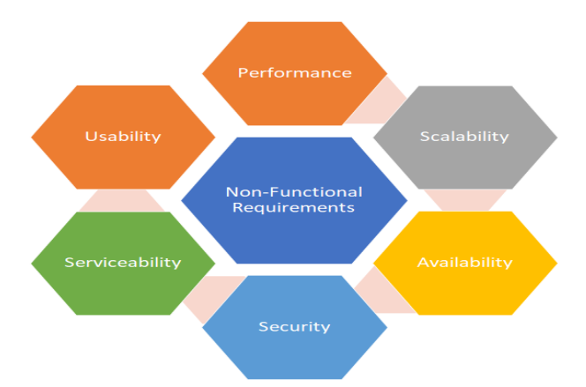

**Fig 3.1: Non-Functional requirements**

Some Non-Functional Requirements are as follows:

**Reliability**

The structure must be reliable and strong in giving the functionalities. The movements must be made unmistakable by the structure when a customer has revealed a couple of enhancements. The progressions made by the Programmer must be Project pioneer and in addition the Test designer.

**Maintainability**

The system watching and upkeep should be fundamental and focus in its approach. There should not be an excess of occupations running on diverse machines such that it gets hard to screen whether the employments are running without lapses.

**Performance**

The framework will be utilized by numerous representatives all the while. Since the system will be encouraged on a single web server with a lone database server outside of anyone's ability to see, execution transforms into a significant concern. The structure should not capitulate when various customers would use everything the while. It should allow brisk accessibility to each and every piece of its customers. For instance, if two test specialists are all the while attempting to report the vicinity of a bug, then there ought not to be any irregularity at the same time.

**Portability**

The framework should to be effectively versatile to another framework. This is obliged when the web server, which s facilitating the framework gets adhered because of a few issues, which requires the framework to be taken to another framework.

**Scalability**

The framework should be sufficiently adaptable to include new functionalities at a later stage. There should be a run of the mill channel, which can oblige the new functionalities.

**Flexibility**

Flexibility is the capacity of a framework to adjust to changing situations and circumstances, and to adapt to changes to business approaches and rules. An adaptable framework is one that is anything but difficult to reconfigure or adjust because of diverse client and framework prerequisites. The deliberate division of concerns between the trough and motor parts helps adaptability as just a little bit of the framework is influenced when strategies or principles change.

**CHAPTER-4**

**SYSTEM DESIGN AND DEVELOPMENT**

**CHAPTER-4**

**SYSTEM DESIGN AND DEVELOPMENT**

System architecture is the process of designing and organizing the components of a system in a way that meets the specific requirements and constraints of the project. It involves making high-level decisions about the organization of the system.

**4.1 System architecture**

A system architecture diagram would be used to show the relationship between different components. Usually, they are created for systems which include hardware and software and these are represented in the diagram to show the interaction between them.

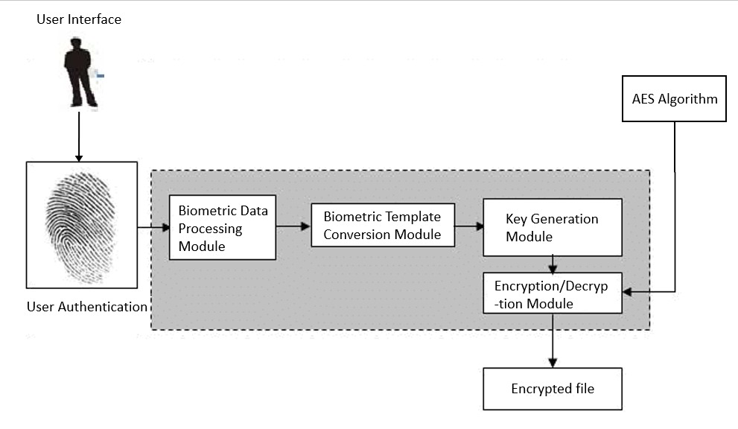

**Fig 4.1 System architecture**

The diagram appears to describe a system related to User Authentication using Biometric Data. Here's a breakdown of the components in the diagram:

User Interface: This is the point of interaction between the user and the system. It could be a graphical user interface (GUI) or a command-line interface (CLI).

User Authentication: This is the process of verifying the identity of a user before allowing access to resources or services. In this context, it's done using biometric data.

Biometric Data: These are unique biological characteristics used for identifying individuals. Examples include fingerprints, facial recognition, iris scans, etc.

Processing Module: This is a component that handles the processing of biometric data. It might involve cleaning the data, normalizing it, or extracting features.

Biometric Template: After processing, the unique features of the biometric data are stored as a biometric template. This template is used for comparison during the authentication process.

Conversion Module: This module might be responsible for converting the biometric data into a format that can be used for key generation.

Key Generation Module: This module generates a key based on the biometric data or its template. This key is unique to the individual.

Encryption/Decryption Module: This module uses the key generated by the Key Generation Module to encrypt or decrypt data. It ensures that only authorized users (those who have provided the correct biometric data) can access the data.

Encrypted File: This is the data that has been encrypted using the Encryption/Decryption Module. It can only be decrypted and accessed by users who have provided the correct biometric data.

AES Algorithm: Advanced Encryption Standard (AES) is a symmetric encryption algorithm used for securing data. It's likely that the Encryption/Decryption Module uses this algorithm for encrypting and decrypting data.

**4.2 Use case diagrams:**

A use case is a set of scenarios that describing an interaction between a source and a destination. A use case diagram displays the relationship among actors and use cases. The two main components of a use case diagram are use cases and actors. shows the use case diagram.The use case diagram shows the relationships between the components and their interactions. The User interacts with the BIO-CRYPT System to authenticate themselves, encrypt data, and decrypt data. The BIO-CRYPT System collects biometric data from the User, generates keys from the biometric data, encrypts data using those keys, and decrypts data using those keys. The Storage system stores the encrypted data and the biometric data.

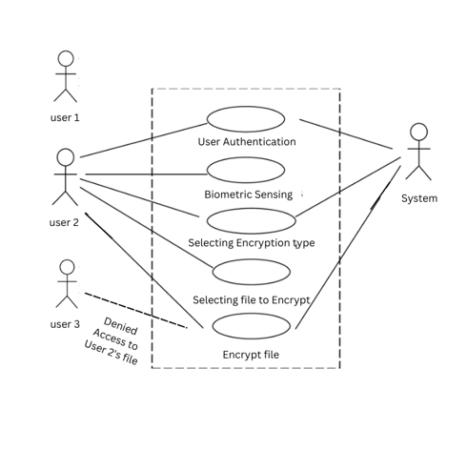

**Fig 4.2 Use case diagram**

* In the above shown use case diagram there are three users using the same system.
* User 2 uses his/her fingerprint for authentication purpose , that fingerprint is converted into keys ,then using AES algorithm the file is encrypted.
* Access is denied for user 3 to read the file.

**CHAPTER-5**

**METHODOLOGY AND IMPLEMENTATION**

**CHAPTER-5**

**METHODOLOGY AND IMPLEMENTATION**

The methodology chapter is a crucial part of your research, serving as a roadmap to the data collection and analysis methods you utilized in your study. This chapter aims to provide a clear understanding of how you conducted your research, allowing readers to evaluate its reliability and validity.

**5.1 Methodology**

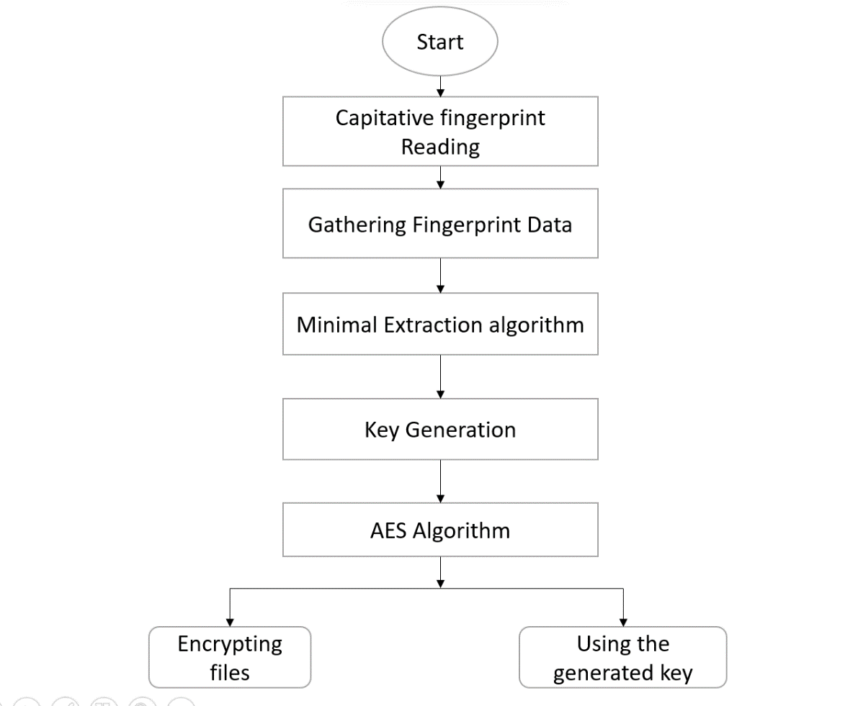

**Fig 5.1: Methodology**

* **Fingerprint Data Acquisition**

The process begins with acquiring high-quality fingerprint data using a capacitive fingerprint scanner. This technology captures intricate details of the fingerprint, providing a reliable foundation for subsequent encryption steps. Ensuring the accuracy and reliability of the capacitive sensor is paramount to the success of the system.

* **Minutiae Extraction Technique:**

Employing advanced minutiae extraction techniques is pivotal for identifying unique ridge and bifurcation points within the fingerprint. Image processing algorithms enhance the accuracy of minutiae extraction, creating a detailed and distinctive fingerprint template. This step forms the basis for subsequent key generation and encryption processes.

* **Feature Encoding and Private Key Generation:**

Transforming minutiae features into a secure private key involves a meticulous feature encoding mechanism. This process converts the minutiae data into a format suitable for cryptographic key generation. Using a secure algorithm, a private key unique to the individual's fingerprint is generated, ensuring a robust and personalized encryption key.

* **AES-128 Bit File Encryption:**The generated private key is utilized in conjunction with the AES-128 bit algorithm to encrypt files securely. The Advanced Encryption Standard (AES) ensures confidentiality and integrity during the encryption process. The choice of a 128-bit key size provides a balance between security and computational efficiency.
* **Secure Storage and Retrieval:**Files are securely stored, and retrieval mechanisms are designed to decrypt them using the stored private key. This process involves establishing a secure file storage system with stringent access controls. Robust security measures are implemented to protect against unauthorized access and data breaches.
* **User Authentication:**Integration of a secure user authentication mechanism ensures that access to encrypted files is granted only after confirming the user's identity. Biometric data, including fingerprint verification, serves as a seamless and secure means of user authentication, enhancing overall system security.
* **Continuous Monitoring and Updates**:  
  To maintain ongoing system security, continuous monitoring is implemented. Regular updates to algorithms and security protocols ensure adaptability to emerging threats and advancements in biometric and cryptographic technologies. This iterative approach guarantees a resilient and up-to-date file encryption system.  
    
  This comprehensive methodology orchestrates the integration of capacitive fingerprint data into a secure encryption framework, ensuring the confidentiality, integrity, and user-friendly accessibility of encrypted files.

**5.2 Implementation**

**Android Studio**

Android Studio is the official Integrated Development Environment (IDE) for Android app development, based on IntelliJ IDEA. On top of IntelliJ's powerful code editor and developer tools, Android Studio offers even more features that enhance your productivity when building Android apps, such as:

1. A flexible Gradle-based build system
2. A fast and feature-rich emulator
3. A unified environment where you can develop for all Android devices
4. Apply Changes to push code and resource changes to your running app without restarting your app
5. Code templates and GitHub integration to help you build common app features and import sample code
6. Extensive testing tools and frameworks
7. Lint tools to catch performance, usability, version compatibility, and other problems
8. C++ and NDK support

**Project structure**

Each project in Android Studio contains one or more modules with source code files and resource files. Types of modules include:

* + Android app modules
  + Library modules
  + Google App Engine modules

Each app module contains the following folders:

* **manifests**: Contains the AndroidManifest.xml file.
* **Kotlin**: Contains the kotlin source code files, including JUnit test code.
* **res**: Contains all non-code resources, such as XML layouts, UI strings, and bitmap images.

**The user interface**

* **The toolbar** lets you carry out a wide range of actions, including running your app and launching Android tools.
* **The navigation bar** helps you navigate through your project and open files for editing. It provides a more compact view of the structure visible in the Project window.
* **The editor window** is where you create and modify code. Depending on the current file type, the editor can change. For example, when viewing a layout file, the editor displays the Layout Editor.
* **The tool window bar** runs around the outside of the IDE window and contains the buttons that allow you to expand or collapse individual tool windows.
* **The tool windows** give you access to specific tasks like project management, search, version control, and more. You can expand them and collapse them.
* **The status bar** displays the status of your project and the IDE itself, as well as any warnings or messages.
* User interface: This module handles interactions with the user. It prompts for authentication, and displays necessary information. It includes components such as:
* Authentication Interface: Provides prompts for users to authenticate themselves using their biometric data.
* File Selection Interface: Allows users to select files they want to encrypt or decrypt.
* User authentication: It captures biometric data. it provides:
* Biometric Data Capture: Responsible for capturing biometric data (e.g., fingerprints, facial recognition).
* Biometric data processing: This module processes and verifies the biometric data provided by the user. It includes:
* Biometric Data Verification: Compares the captured biometric data with stored biometric templates for user authentication.
* Biometric Data Storage: Stores securely encrypted biometric templates associated with authorized users.
* Biometric Template Conversion Module: This module takes in users' fingerprint data converts it into token and stores it in the keyStore of users' device
* Key Generation Module: This module is responsible for generating encryption key by using token generated after biometric sensing.
* Encryption/Decryption Module: This module handles the actual encryption and decryption of files. It includes:
* Encryption: Takes user-selected files and encrypts them using a strong encryption algorithm (e.g., AES) and a randomly generated key.
* Decryption: Decrypts encrypted files using the appropriate key aftersuccessful user **authentication.**

**CHAPTER- 6**

**TESTING AND VALIDATION**

**CHAPTER- 6**

**TESTING AND VALIDATION**

Testing and validation are crucial steps in the software development process. They ensure that the product being developed meets the desired requirements and functions as expected.

**6.1 Testing**

Testing for BIO-CRYPT, which involves biometric encryption and authentication, is crucial to ensure the system's functionality, security, and reliability. Some testing approaches that can be employed for the BIO-CRYPT project include:

1. Unit Testing: Testing individual components of the system, such as biometric data capture modules, encryption algorithms, and authentication mechanisms, to verify their correctness and functionality in isolation.

2. Integration Testing: Testing the integration of different system components to ensure they work together seamlessly. This can involve testing how biometric data is captured, processed, and used for encryption and authentication within the system.

3. Functional Testing: Testing the system's functionality against specified requirements to ensure that it performs the intended operations correctly. This can include testing biometric data capture, encryption key generation, authentication processes, and data encryption and decryption.

4. Security Testing: Conducting security testing to identify and address vulnerabilities in the system that could be exploited by attackers. This can involve penetration testing, vulnerability scanning, and security assessments to ensure the system is resistant to unauthorized access and data breaches.

5. Performance Testing: Evaluating the system's performance under various conditions, such as different user loads and network speeds, to ensure it meets performance requirements. Performance testing can help identify bottlenecks, optimize system resources, and ensure smooth operation under different scenarios.

6. Usability Testing: Testing the system's user interface, user experience, and overall usability to ensure it is intuitive and easy to use for end-users. Usability testing can help identify any usability issues and improve the user experience of the system

7. Regression Testing: Conducting regression testing to ensure that new updates or changes to the system do not introduce new bugs or issues. Regression testing can help maintain the system's stability and reliability throughout its development lifecycle.

By implementing these testing approaches, the BIO-CRYPT project can validate its functionality, security, performance, and usability, ensuring that it meets the requirements for secure biometric encryption and authentication. Testing is essential to identify and address any issues or vulnerabilities in the system, providing confidence in its effectiveness and reliability for protecting sensitive data using biometric technology.

**6.2 Validation**

The validation for a project like BIO-CRYPT, which leverages biometric data for encryption and authentication purposes, can involve several aspects to ensure its effectiveness, security, and reliability. Some validation methods for the BIO-CRYPT project could include:

1. Accuracy Testing: Conducting accuracy testing to evaluate the system's ability to correctly authenticate users based on their biometric data. This can involve comparing the biometric data captured by the system with known reference data to assess the accuracy of the authentication process.

2.Security Assessment: Performing security assessments to identify and address potential vulnerabilities in the system. This can include penetration testing, vulnerability scanning, and threat modeling to ensure that the system is resistant to unauthorized access and cyber threats .

3.Usability Testing: Conducting usability testing to evaluate the user experience of the system. This can involve testing the ease of use, user interface design, and overall user satisfaction with the authentication and encryption processes.

4.Performance Evaluation: Assessing the performance of the system under various conditions, such as high user loads or network latency. Performance evaluation can help determine the system's responsiveness, scalability, and efficiency in handling authentication and encryption tasks.

5.Compliance Verification: Ensuring that the system complies with relevant regulations and standards for data security and privacy. This can involve verifying compliance with industry standards such as GDPR, HIPAA, or ISO/IEC 27001 to demonstrate the system's adherence to best practices in data protection.

6.Feedback from Stakeholders: Gathering feedback from stakeholders, including users, administrators, and security experts, to assess their satisfaction with the system and identify areas for improvement. Incorporating feedback from stakeholders can help refine the system and address any usability or security concerns.

By implementing these validation methods, the BIO-CRYPT project can demonstrate its effectiveness, security, and usability in leveraging biometric data for encryption and authentication purposes. Validation is essential to ensure that the system meets the intended objectives, complies with security standards, and provides a reliable and user-friendly solution for secure authentication and data protection.

**CHAPTER-7**

**RESULTS AND DISCUSSION**

**CHAPTER-7**

**RESULTS AND DISCUSSION**

The results chapter is a crucial part of any research report, as it presents the main findings of your study. This chapter should be written in a clear and concise manner, reporting all relevant results objectively and in a logical order. It's important to avoid subjective interpretations or speculations about the meaning of the results in this section, as those should be saved for the discussion chapter.

**7.1 Results**

The result of the BIO-CRYPT project, which focuses on enhancing security with biometric encryption, is a system that leverages biometric data such as fingerprints, iris scans, or facial features to create a robust encryption architecture. The core of the system involves encoding and decoding confidential information using biometric keys generated from unique biological markers. Advanced algorithms are utilized to authenticate authorized users based on their biometric data, granting access only after successful authentication.

The BIO-CRYPT system aims to provide a dynamic approach to enhancing data security through the inherent uniqueness of biometrics. It offers versatility across various domains, from access control to financial transactions, by ensuring that only authorized users can access encrypted data through biometric authentication. The system addresses challenges such as privacy concerns, potential vulnerabilities, and the need for robust data protection measures.

Ongoing research efforts are focused on improving the adaptability and reliability of the BIO-CRYPT system. Further development is essential to realize its full potential in providing a secure and user-friendly solution for data encryption and authentication using biometric technology. The project highlights the importance of continuous refinement and enhancement to address emerging security challenges and ensure the effectiveness of biometric encryption in safeguarding sensitive information. The BIO-CRYPT project represents an innovative approach to data security by integrating biometric technology into encryption and authentication processes. By leveraging biometric data as the basis for secure access control and data protection, the system offers a promising solution for enhancing security measures across diverse industries and applications.

* Biometric authentication

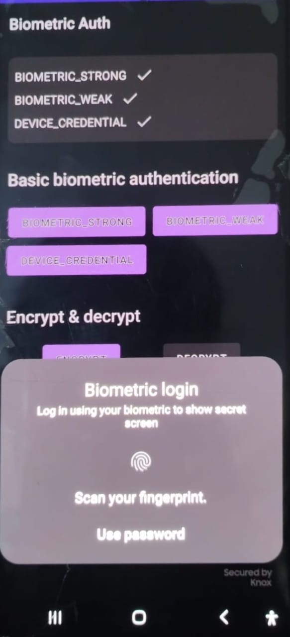

**Fig 7.1: Biometric authentication**

Biometric authentication is a security mechanism that uses unique biological characteristics of users, such as fingerprints, facial features, or iris patterns, to authenticate their identity. In the context of mobile applications, biometric authentication can be used to enhance the security of sensitive data and transactions. The page prompts the user to authenticate their identity using their biometric credentials, such as fingerprints or facial recognition. The page includes a title, a subtitle, and a negative button that allows the user to cancel the authentication process and use their account password instead. The page also includes a confirmation required flag that specifies whether the user must confirm their biometric credential after it is accepted.

* Landing screen

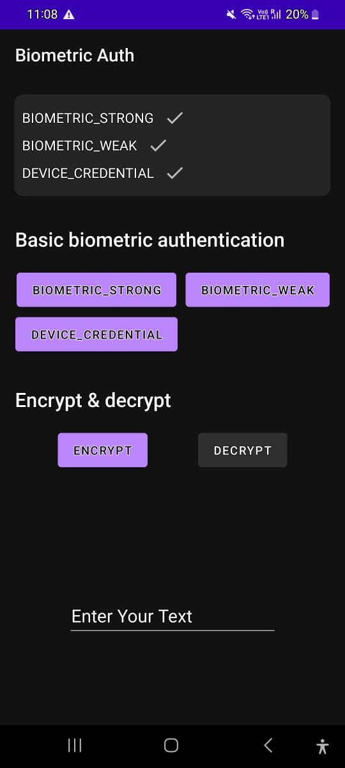

**Fig 7.2: Landing Screen**

This page provides you with an intuitive interface to securely encrypt and decrypt your files using advanced encryption algorithms. You will find two buttons: Encrypt and Decrypt. The Encrypt button allows you to select a file from your device and encrypt it using the selected encryption algorithm. The Decrypt button, on the other hand, allows you to decrypt a previously encrypted file using the appropriate decryption key.

Below the Encrypt and Decrypt buttons, you will find two additional options: Strong Encryption and Weak Encryption. These options allow you to choose the level of security for your encrypted files. The Strong Encryption option uses advanced encryption algorithms such as AES-256 to provide maximum security for your files. This option is recommended for sensitive files that require a high level of protection. The Weak Encryption option, on the other hand. While this option may be sufficient for less sensitive files, it is not recommended for files that contain confidential or sensitive information.

* Encryption

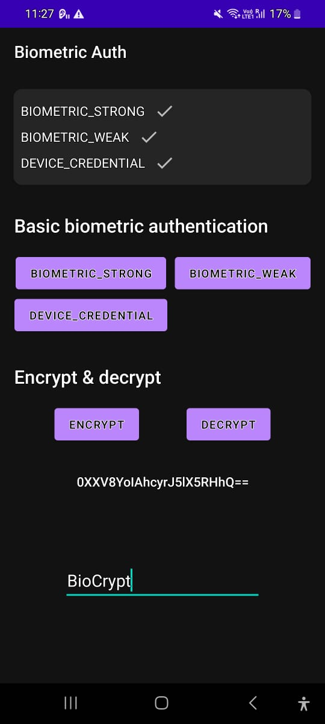

**Fig 7.3 Encryption screen**

The encryption screen is a crucial component of the mobile application, responsible for securing user data by applying advanced encryption techniques. In this particular case, the screen utilizes AES (Advanced Encryption Standard) to encrypt data, ensuring its confidentiality and protection from unauthorized access.

Upon entering the encryption screen, users are presented with a clear and intuitive interface. The screen may display the data to be encrypted, typically in a text field, along with an option to select the desired encryption key size. The text biocrypt is been encrypted and given as some other text using the users biometric.

* Decryption

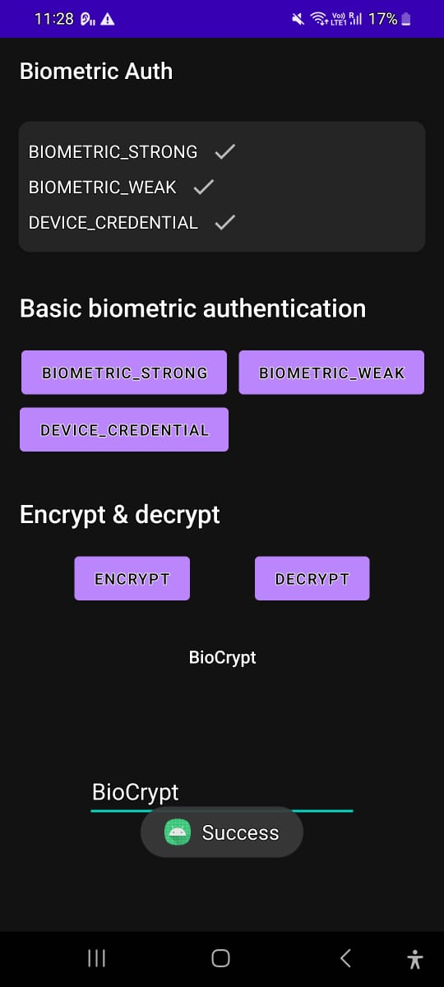

**Fig 7.4 Decryption screen**

This mobile application page is dedicated to the decryption of BIO-CRYPT Encryption using biometric data with AES. The page contains code for initializing a biometric prompt, generating a secret key, and encrypting sensitive information. The previously encrypted message is decrypted here as shown in the above snapshot.

**CHAPTER-8**

**CONCLUSION AND FUTURE ENHANCEMENT**

**CHAPTER-8**

**CONCLUSION AND FUTURE ENHANCEMENT**

A chapter conclusion is a critical part of any written work as it provides a sense of closure to the events, ideas, and arguments presented in the chapter. It is an opportunity to summarize the main points, highlight the significance of the chapter.

**8.1 Conclusion**

The conclusion of the BIO-CRYPT project, which focuses on enhancing security with biometric encryption, highlights the innovative encryption paradigm that leverages biometric data to enhance security measures. The system incorporates fingerprint biometric features as the foundation of a robust encryption architecture, emphasizing the encoding and decoding of confidential information using biometric keys generated from distinctive biological markers.

Throughout the project, the BIO-CRYPT system has demonstrated versatility across various domains, from access control to financial transactions, by providing a dynamic and personalized security layer that adapts to individual biometric characteristics. By integrating biometric data into encryption keys and authentication processes, the system offers a robust defense mechanism against unauthorized access, enhancing accuracy and security.

The project underscores the importance of ongoing research and development efforts to address challenges such as privacy concerns, potential vulnerabilities, and the need for robust data protection measures. By continuously refining the technology and algorithms used in BIO-CRYPT, the project aims to improve adaptability, reliability, and user-friendliness, ensuring that biometric key generation emerges as the future of secure authentication.

The BIO-CRYPT project represents a significant advancement in data security by leveraging biometric technology to enhance encryption and authentication processes. By utilizing biometric data as a unique identifier and encryption key, the system offers a promising solution for securing sensitive information and ensuring authorized access. The project's focus on innovation, security, and user-centric design positions BIO-CRYPT as a valuable contribution to the field of biometric encryption and data security.

BIO-CRYPT introduces an innovative encryption paradigm leveraging biometric data to enhance security measures. The system incorporates fingerprint biometric features as the foundation of a robust encryption architecture. This paper elucidates the BIO-CRYPT architecture, outlining the primary mechanisms for acquiring biometric data, transforming it into an encryption key, and subsequently encrypting the data. At the heart of BIO-CRYPT lies the encoding and decoding of confidential information utilizing biometric keys generated from distinctive biological markers. The system employs advanced algorithms to authenticate authorized users based on biometric data, permitting access only upon successful authentication.

**8.2 Future Enhancement**

The future enhancements of BIO-CRYPT could focus on further refining the system to address existing challenges and improve its adaptability and reliability. Some potential areas for enhancement include:

1.Improved Biometric Data Processing: Enhancing the algorithms and techniques used for processing biometric data, such as fingerprints, iris scans, or facial features, can lead to more accurate and efficient biometric key generation. By optimizing the data processing methods, BIO-CRYPT can improve the overall security and reliability of the encryption system.

2. Enhanced Security Measures: Implementing additional security measures, such as multi-factor authentication or biometric fusion techniques, can further strengthen the security of BIO-CRYPT. By combining different biometric modalities or adding supplementary authentication factors, the system can provide an even higher level of security against unauthorized access.

3. Integration with Emerging Technologies: Integrating BIO-CRYPT with emerging technologies like blockchain or artificial intelligence can enhance the system's capabilities and security features. By leveraging these advanced technologies, BIO-CRYPT can stay at the forefront of secure authentication methods and adapt to evolving security threats.

4. Scalability and Interoperability: Enhancing the scalability and interoperability of BIO-CRYPT to work seamlessly across different platforms and systems can increase its usability and adoption in various domains. By ensuring compatibility with existing security infrastructures and standards, BIO-CRYPT can be more widely implemented and integrated into diverse applications.

5.User Experience and Accessibility: Improving the user experience and accessibility of BIO-CRYPT through user-friendly interfaces, streamlined processes, and intuitive design can enhance its usability and acceptance among users. By prioritizing user experience, BIO-CRYPT can become a more user-centric and efficient security solution.

Overall, the future enhancements of BIO-CRYPT could focus on refining the system's biometric data processing, enhancing security measures, integrating with emerging technologies, improving scalability and interoperability, and enhancing user experience and accessibility. By continuously evolving and adapting to meet the changing needs of the security landscape, BIO-CRYPT can remain a cutting-edge solution for secure authentication and data encryption.

**REFERENCES**

* [1] S. N. Yanushkevich, ‘‘Synthetic biometrics: A survey,’’ in Proc. IEEE Int. Joint Conf. Neural Netw., Jul. 2020, pp. 676–683.
* [2]Bakheet, S., et al., Robust Fingerprint Minutiae Extraction and Matching Based on Improved SIFT Features. Applied Sciences, 2022. 12(12): p. 6122.
* [3]Jamil, A.S., R.A. Azeez, and N.F. Hassan, An Image Feature Extraction to Generate a Key for Encryption in Cyber Security Medical Environments. International Journal of Online & Biomedical Engineering, 2023. 19(1).
* [4] Abusham, E., et al., Facial image encryption for secure face recognition system. Electronics, 2023. 12(3): p. 774.
* [5] Prof. Luciano Margara, Prof. Davide Maltoni, ‘‘Minute Extraction technique” Oct. 2020, pp. 251–256.
* [6]Peralta, D., et al., Minutiae filtering to improve both efficacy and efficiency of fingerprint matching algorithms. Engineering Applications of Artificial Intelligence, 2014. 32: p. 37-53.
* [7] Lu, H., et al. Face recognition with biometric encryption for privacy-enhancing self-exclusion. in 2009 16th International Conference on Digital Signal Processing. 2009. IEEE.
* [8]Cole, O. and K. El-Khatib. A privacy enhanced facial recognition access control system using biometric encryption. in 2017 13th International Conference on Distributed Computing in Sensor Systems (DCOSS). 2017. IEEE.
* [9]Peralta, D., et al., Minutiae filtering to improve both efficacy and efficiency of fingerprint matching algorithms. Engineering Applications of Artificial Intelligence, 2014. 32: p. 37-53.
* [10]Bengueddoudj, A., et al. Improving fingerprint minutiae matching using local and global structures. in 2013 8th International Workshop on Systems, Signal Processing and their Applications (WoSSPA). 2013. IEEE.